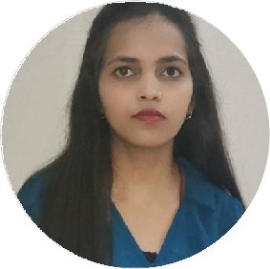
Puja Kumari
Software Engineer

B.Tech graduate with hands-on experience in Java, C++, HTML, CSS, JavaScript, MySQL, and Web Development. Completed internship experience in software development and developed academic projects in Android Application Development and Machine Learning. Strong understanding of Data Structures, Object-Oriented Programming, and Database Management Systems. Seeking an entry-level Software Engineer role to contribute technical skills and grow within a reputed IT organization.

pujakumaripal96@gmail.com

9472260535

Pal mansion beldarichak, Patna, India
linkedin.com/in/puja-kumari-840298335

https://github.com/PUJA9628271

SKILLS

Good Communication skills
C& C++
HTML
CSS
JAVA

Problem -Solving
Problem -Solving

EDUCATION

B.Tech in computer science and engineering

Ms Ramaiah University of Applied Sciences Bangalore
09/2019 - 09/2024 Bangalore,India 7.3CGP

Higher Secondary school
Sr.Secondary +2 school punpun, Patna
05/2015 - 04/2017 Patna,India 60%

High school patna

ST.Joseph's High school patna
04/2013 - 05/2015 Patna,India 5.2 CGP

WORK EXPERIENCE

Software developer

Bharat Intern
12/2022 - 08/2023 Bangalore, Karnataka
Developed and maintained web application using technologies such as HTML,CSS, JavaScript,React.Js and Angular.Js and strong understanding of data structures and object-oriented programming concepts.Experience with MYSQL for database management.Familiarity with React.Js and Angular .Js for Front-End Development.

Data Structure

Object Oriented programming language
Microsoft Office
MYSQL
Problem -Solving

LANGUAGES

English
Full Professional Proficiency

Hindi
Full Professional Proficiency

INTERESTS

Badminton

Travelling
Cooking

CERTIFICATES

The sparks Foundation (11/2022 - 12/2022)
JAVASCRIPT
Web Development

Java programming Language (02/2022 - 06/2022)
Coursera

Development and Advanced Engineering Virtual Experience (10/2022 - 11/2022)
Accenture

Artificial intelligence Virtual Experience peogram (11/2022 - 11/2013)
Cognizant

Android Application Development (11/2022 - 11/2023)
Great Learning

PERSONAL PROJECTS

Android Chat Application Technologies: Java, Firebase, Android Studio

Developed a real-time chat application supporting instant messaging.

Integrated Firebase Realtime Database for message synchronization.

Implemented user authentication and group communication features.

Chronic Kidney Disease Prediction System Technologies: Python, Machine Learning

Developed a machine learning model for disease prediction.

Performed data preprocessing and model evaluation.

Improved prediction accuracy using classification algorithms.

